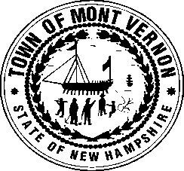
TOWN OF MONT VERNON
Office of the Selectmen
P. O. Box 444
Mont Vernon, NH 03057
603-673-6080

Monday, March 11, 2024
Agenda

7:00 PM Public Time
7:15 PM Department Head Meeting
7:45 PM Town Meeting Final Details

Current Business

Approvals

Minutes of 3/4/24

Old Business
Junkyards
Tax Deeded Property - Weston Hill – Atty. Quinn

