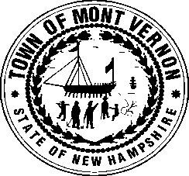
TOWN OF MONT VERNON
P. O. Box 444
Office of the Selectmen
Mont Vernon, NH 03057
603-673-6080

Wednesday, October 2, 2023
Agenda

7:00 PM Public Time
7:15 PM Second NH Turnpike
7:45 PM Planning Board Member Appointments
8:00 PM 3rd Quarter Budget Review

Current Business

Approvals

Minutes of 9/25/23

Old Business

Junkyards
Tax Deeded Property - Weston Hill – Atty. Quinn

