APPENDIX B: TRANSPORTATION
This appendix provides all of the supporting data that are used in the Transportation report.
Road Inventory
Roadway Classifications
Roads and highways are classified by the NH Department of Transportation (NH DOT) according to state legislative class and federal functional class.

State Legislative Classification
State legislative class is defined by RSA 229 – 231 and is used to determine responsibility for construction, reconstruction, and maintenance, as well as eligibility for use of state-aid funds. Information on the state classification of highways and state highway and bridge aid funds can be found at the NH DOT’s Planning and Community Assistance website (http://www.nh.gov/dot/org/projectdevelopment/planning/documents.htm).
Table T-5 below provides a general description the state legislative classification system and the extent of each class in Mont Vernon. Map T-1 in the body of the transportation chapter of this plan displays the road network by state class.
Table T-5: State Aid Road Classification in Mont Vernon
Legislative Class | Characteristics | Mileage
Class I | - Consists of all existing or proposed highways on the primary state highway system.  - Maintained by the State. | 0 miles
Class II | - Consists of all existing or proposed highways on the secondary state highway system.  - Maintained by the State. | 6.6 miles
Class III | - Consists of all such roads leading to and within state parks and reservations.  - Maintained by the State. | 0 miles
Class IV | - Consists of all highways within the compact section of cities and towns listed in RSA 229:5, V. (Urban Compacts). | 0 miles
Class V | - Consist of all other traveled highways that the town or city has the responsibility to maintain. | 41.1 miles
Class VI | - Consist of all other existing public ways, including highways subject to gates, and highways not maintained in suitable condition for travel for five years or more. | 2.6 miles
Total maintained (excluding Class VI):  Total including Class VI: |  | 47.7 miles  50.3 miles
Source: NH DOT

Federal Functional Classification
A Federal Functional Class is assigned to all public roads using Federal Highway Administration guidelines and is used to determine which roads are eligible for federal-aid funds. Federal functional classification is the process by which streets and highways are grouped into classes or systems, according to the type of service they are intended to provide. It reflects a highway’s balance between providing land access versus mobility. In general, roads are classified as urban or rural based on US Census data, then as arterials, collector roads, or local roads, based on function. According to the 2010 US Census, the majority of Mont Vernon is designated as rural, however, a small area along the Milford boundary between Old Wilton Road and Old Milford Road is designated as urban. The NH DOT is in the process of reviewing and updating road classifications as a result of the revised boundaries, but that effort will not be completed until 2013. The only Mont Vernon roads in the urban area are local and private roads, and it is unlikely that they will be upgraded to collectors through the NH DOT classification review.
Table T-6 below provides a general description the functional classification system of the roads in Mont Vernon and the mileage of each class; Map T-7 below displays the road network by federal functional class. Detailed classification concepts, definitions, and characteristics from the Federal Highway Administration are available online at: http://www.fhwa.dot.gov/planning/processes/statewide/related/functional_classification/fc01.cfm
Map T-7: Federal Functional Classification in Mont Vernon
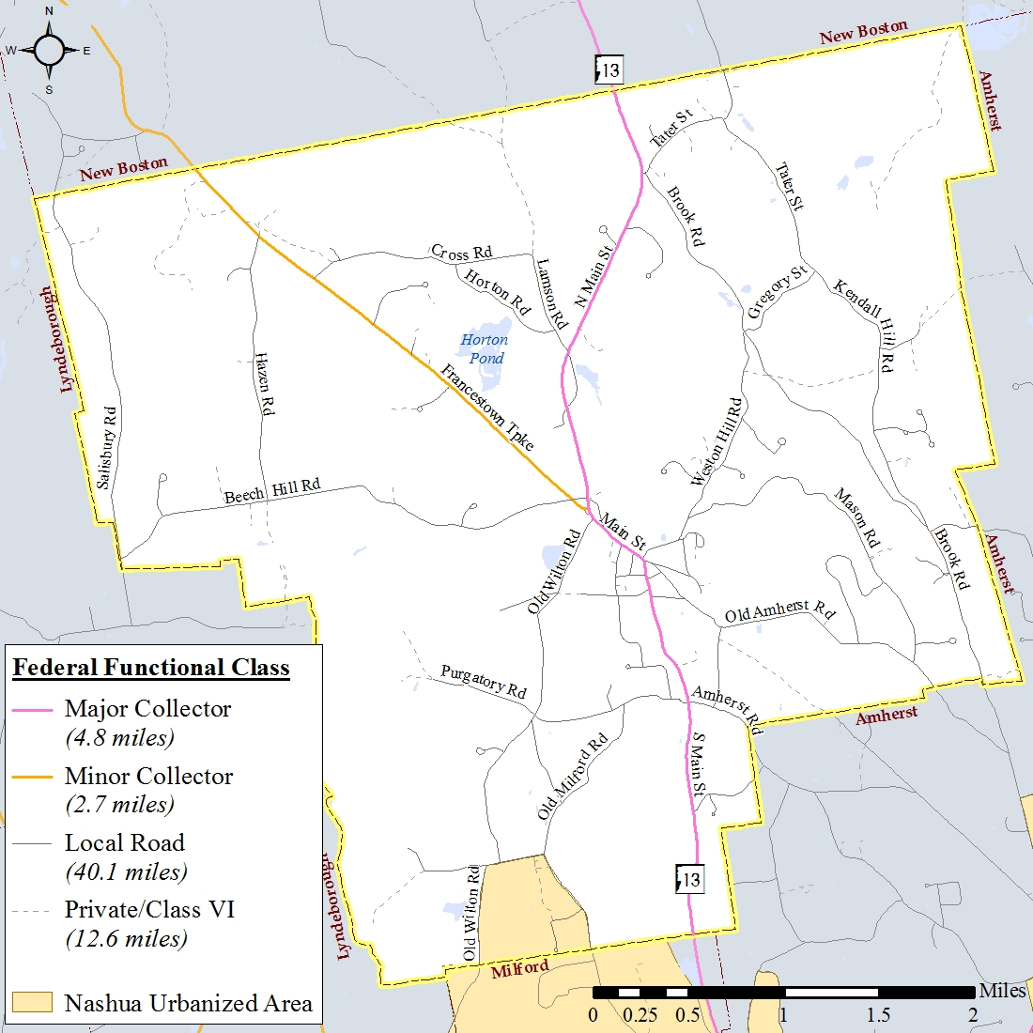
Table T-5: Federal Functional Classification of Mont Vernon Roads
Source: NH DOT
Functional Class | Characteristics | Mileage
Principal Arterial | - Provides the highest level of mobility at the greatest travel speeds, providing long distance connections between major trip generators (larger cities, recreational areas, etc.)  - Three subcategories: Interstate, Freeway/Expressway, and Other Principal Arterial  - Eligible for federal aid | 0 miles
Minor Arterial | - Provides access to geographic areas smaller than those served by the higher system by linking towns and cities together  - Can provide the highest level of mobility through rural areas without principal arterials, while providing important connections between the principal arterial and collector network in urban areas  - Eligible for federal aid | 0 miles
Major/Urban Collector | - Provides service to any county seat not on an arterial route; to the larger towns not directly served by the higher systems; and to other traffic generators of equivalent intracounty importance, such as consolidated schools, shipping points, recreational areas, etc.  - Provides links to nearby larger towns or cities, or with routes of higher classifications.  - In urban areas, provides both land access service and traffic circulation within residential neighborhoods, commercial and industrial areas  - Serves the more important intracounty travel corridors.  - Eligible for federal aid. | 4.8 miles  (NH 13)
Minor Collector  (rural areas only) | - Collects traffic from the local roadway network and distributes it to the major collector or arterial system.  - Provides service to smaller municipalities.  - Provides links to important small scale land use serving the local community. | 2.7 miles  (Francestown Tpke)
Local | - Comprises all highways not on the higher systems.  - Provides the lowest level of mobility by accessing adjacent land use, serving local trip purposes, and connecting to higher order roadways. | 40.1 miles
Total: |  | 47.6 miles
Source: NH DOT

Road Surface Management System Analysis
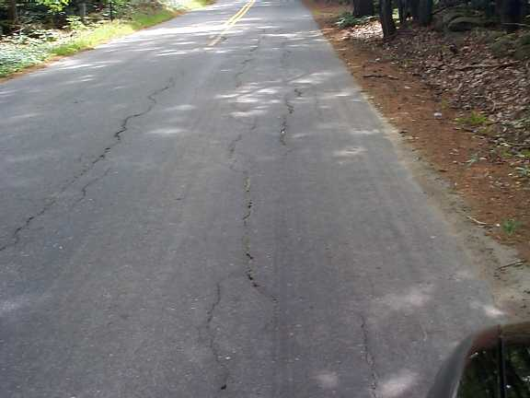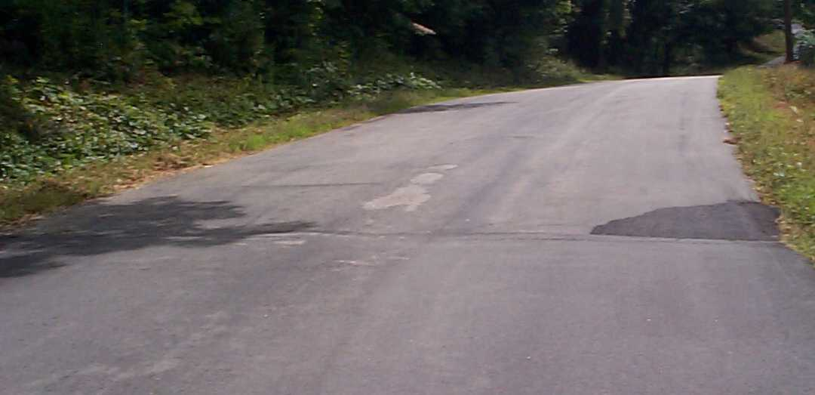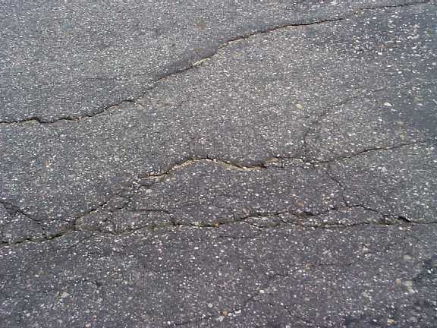
Examples of Alligator, Longitudinal, Transverse and Edge Cracking
Road Surface Management System (RSMS) software uses user-observed pavement conditions to calculate a Pavement Condition Index, then generates a repair strategy and ten-year budget projections by matching a repair strategy to each road or road segment based on the extent and severity of the distress and the weight given by the user for the volume of traffic on the road. The degradation of pavement condition over time, improvements in pavement condition due to implemented repairs, and cost inflation for repairs that are not implemented are taken into account by the software. The repair strategies are initially selected without budget constraints; the Road Agent can then tailor each repair strategy based on a town’s preferences and estimated annual budget. A UNH publication titled "RSMS Explained" is included in this appendix.
In November 2012, NRPC staff completed a visual survey of paved and unpaved road conditions in Mont Vernon. Local (Class V) roads that the town is responsible for maintaining were evaluated on seven criteria: patching/potholes, edge cracking, drainage, longitudinal/transverse cracking, rutting, alligator cracking, and roughness. The condition data is input into the RSMS software, which uses the input to calculate a Pavement Condition Index (PCI) for each road segment. Road importance and traffic volume data is also input into the software. Roads that carry the most traffic, or have schools, hospitals, and/or critical services on them are generally the most important and the software uses that information when determining effective strategies. Based on the road importance, volume and condition data, the RSMS software generated repair alternatives for each road segment which are displayed on Map T-2 in the body of the Transportation Chapter and detailed in the following tables.
A “straight 70% analysis” was completed by assigning repairs in years when the PCI falls below 70% without regard for creating a predictable annual budget. That analysis is provided as an example; NRPC would like to work with Mont Vernon Highway Department officials to develop a multi-year maintenance plan with the town's input on the road importance, estimated annual budgets, repair strategies with associated costs, and specific repairs and timing.

Table T-6: Repairs by Cost and Year
Year 1 | Road | From : To | Length (mi) | Repair | Cost
 | Rangeway Rd | Purgatory Rd : Kittredge Rd | 0.29 | 1.5" HMA overlay | $20,651
 | Old Amherst Rd | Main St : Smith Rd | 0.04 | Fill/seal cracks | $102
 | Rangeway Rd | Kittredge Rd : End | 0.13 | 1.5" HMA overlay | $10,055
 | Old Wilton Rd | Trow Rd : Trappist Cir | 0.22 | 1.5" HMA overlay | $14,170
 | Old Wilton Rd | Trappist Cir : Hutchinson Rd | 0.63 | 1.5" HMA overlay | $39,822
 | Cotton Pl | N. Main St : End | 0.05 | 1.5" HMA overlay | $3,479
 | Hillcrest Ave | S. Main St : Old Amherst Rd | 0.17 | 1.5" HMA overlay | $8,755
 | Mobile Coach Ln | Olf Milford Rd : Third St | 0.18 | 1.5" HMA overlay | $11,458
 | Trappist Cir | Old Wilton Rd : End | 0.23 | Ditch, replace 6" base, 2" surface | $52,312
 | Old Francestown Tpk | Francestown Tpk : End | 0.04 | 1.5" HMA overlay | $2,826
 | Southview Dr | Westin Hill Rd : End | 0.20 | 1.5" HMA overlay | $15,055
 | Beech Hill Rd | Chestnut Cir : Hazen Dr | 1.09 | Ditch, fill/seal cracks | $3,855
 | Gavin Rd | Brook Rd : Amherst T/L | 0.27 | Ditch, fill/seal cracks | $964
 | Old Wilton Rd | Dow Rd : Milford T/L | 0.53 | 1.5" HMA overlay | $33,582
 | Pond Rd | N. Main St : N. Main St | 0.31 | 1.5" HMA overlay | $15,730
 | Kittredge Rd | Rangeway Rd : Pavement Change | 0.33 | 1.5" HMA overlay | $25,259
 | Sean Dr | N. Main St : End | 0.21 | 1.5" HMA overlay | $16,373
 | Weston Hill Rd | Grand Hill Rd : Mason Rd | 0.13 | Ditch, fill/seal cracks | $457
 | Grand Hill Rd | Boutwell Rd : End | 0.27 | Ditch, fill/seal cracks | $971
 | Grand Hill Rd | Weston Hill Rd : Boutwell Rd | 0.03 | 1.5" HMA overlay | $1,825
 | Lamson Rd | Cross Rd : Horton Rd | 0.42 | Regrade | $3,281
 | Kendall Hill Rd | Remington Rd : Gregory St | 0.56 | Ditch, fill/seal cracks | $1,988
 | Weston Hill Rd | Mason Rd : Cariage Cir | 0.25 | Ditch, replace 6" base, 2" surface | $47,315
 | Levesque Ln | N. Main St : Change in Pavement | 0.33 | 1.5" HMA overlay | $25,542
 | Joe English Rd | Tater St : End of Pavement | 0.03 | Ditch, replace 6" base, 2" surface | $4,449
 | Purgatory Rd | Walter Hill Rd : Pavement Change | 0.11 | Ditch, fill/seal cracks | $384
 | Old Milford Rd | Purgatory Rd : Pavement Change | 0.28 | Ditch, replace 6" base, 2" surface | $47,901
 | Total for Year 1: |  |  |  | $408,561
Year 2 | Road | From : To | Length (mi) | Repair | Cost
 | Smith Rd | Old Amherst Rd : Boutwell Rd | 0.21 | Regrade | $1,126
 | Old Milford Rd | Pavement Change : Trow Rd | 0.39 | 1.5" HMA overlay | $22,815
 | Cross Rd | Francestown Tpk : Twin Maple Ln | 0.13 | 1.5" HMA overlay | $7,082
 | Old Milford Rd | Mobil Coach Ln : Milford T/L | 0.22 | 1.5" HMA overlay | $14,498
 | Bear Brook Way | Brook Rd : End | 0.22 | Regrade | $1,746
 | Beech Hill Rd | Greenwood Way : Margaret Cir | 0.36 | Ditch, fill/seal cracks | $1,309
 | Spring Hill Rd | Mason Rd : Old Amherst Rd | 0.96 | 1.5" HMA overlay | $69,699
 | Mason Rd | Taschereau Dr : Spring Hill | 0.38 | 1.5" HMA overlay | $25,168
 | Total for Year 2: |  |  |  | $143,444

Table T-6: Repairs by Cost and Year (continued)
Year 3 | Road | From : To | Length (mi) | Repair | Cost
 | Westgate Rd | Kendall Hill Rd : First Cul-De-Sac | 0.16 | Ditch, fill/seal cracks | $611
 | Cross Rd | Endof Pavement : Horton Rd | 0.60 | Reshape-Blade/Drag | $4,479
 | Kendall Hill Rd | Brook Rd : Westgate Rd | 0.59 | Ditch, fill/seal cracks | $2,209
 | Upton Rd | 0Ld Wilton Rd : Gun Club | 0.31 | Reshape-Blade/Drag | $1,750
 | Weston Hill Rd | Carriage Cir : Southview Dr | 0.09 | Ditch, fill/seal cracks | $340
 | Beech Hill Rd | Pavement Change : Chestnut Cir | 0.41 | Ditch, fill/seal cracks | $1,545
 | Hutchinson Rd | Old Wilton Rd : Third St | 0.18 | Hot Mix Patch | $5,216
 | Tater St | Pavement Change : Gregory St | 0.52 | 1.5" HMA overlay | $37,284
 | Old New Boston Rd | N. Main St : End of Pavement | 0.14 | Ditch, fill/seal cracks | $544
 | Cross Rd | Twin Maple Ln : End of Pavement | 0.06 | Ditch, fill/seal cracks | $233
 | Weston Hill Rd | End of Pavement : Herlihy Rd | 0.04 | Reshape-Blade/Drag | $314
 | Old Amherst Rd | Conant Ave : Pavement Change | 0.08 | 1.5" HMA overlay | $5,438
 | Total for Year 3: |  |  |  | $59,964
Year 4 | Road | From : To | Length (mi) | Repair | Cost
 | Old Amherst Rd | Spring Hill Rd : Mason Rd | 0.31 | Ditch, fill/seal cracks | $1,223
 | Old Amherst Rd | Mason Rd : Amherst T/L | 0.17 | 1.5" HMA overlay | $13,342
 | Old Wilton Rd | Upton Rd : Purgatory Rd | 0.69 | Ditch, fill/seal cracks | $2,692
 | Hazen Rd | Dalan Cirlce : Francestown Tpk | 0.18 | Ditch, fill/seal cracks | $711
 | Horton Rd | Cross Rd : Lamson Rd | 0.68 | Reshape-Blade/Drag | $5,234
 | Taschereau Dr | Mason Rd : End | 0.29 | 1.5" HMA overlay | $23,966
 | Pine Knoll Dr | Secomb Rd : End | 0.15 | 1.5" HMA overlay | $11,341
 | Weston Hill Rd | Herlihy Rd : Brook Rd | 0.22 | Reshape-Blade/Drag | $1,658
 | Lamson Rd | Horton Rd : Start of Pavement | 0.09 | Reshape-Blade/Drag | $767
 | Weston Hill Rd | Grand Hill Rd : Mason Rd | 0.13 | Ditch, fill/seal cracks | $502
 | Purgatory Rd | Walter Hill Rd : Pavement Change | 0.11 | Ditch, fill/seal cracks | $422
 | Total for Year 4: |  |  |  | $61,858

Table T-6: Repairs by Cost and Year (continued)
Year 5 | Road | From : To | Length (mi) | Repair | Cost
 | Harwood Rd | End of Pavement : End | 0.17 | Reshape-Blade/Drag | $1,195
 | Purgatory Rd | Old Wilton Rd : End | 0.88 | Reshape-Blade/Drag | $6,974
 | Cemetery Rd | Main St : Pinkham Ave | 0.18 | Reshape-Blade/Drag | $1,565
 | Cemetery Rd | Pinkham : Harwood Rd | 0.10 | Fill/seal cracks | $265
 | Grand Hill Rd | Main St : Weston Hill Rd | 0.22 | Ditch, fill/seal cracks | $880
 | Trow Rd | Old Milford Rd : Old Wilton Rd | 0.47 | Reshape-Blade/Drag | $3,278
 | Deer Brook Way | Brook Rd : End | 0.09 | Reshape-Blade/Drag | $763
 | Gavin Rd | Brook Rd : Amherst T/L | 0.27 | Ditch, fill/seal cracks | $1,094
 | Secomb Rd | Amherst T/L : Pine Knoll Dr | 0.27 | Reshape-Blade/Drag | $1,618
 | Old Milford Rd | Trow Rd : Hutchinson Rd | 0.29 | Ditch, fill/seal cracks | $1,155
 | Tater St | N. Mainst. : Brook St | 0.02 | Ditch, fill/seal cracks | $69
 | Kendall Hill Rd | Westgate Rd : Herlihy Rd | 0.33 | Hot Mix Patch | $10,110
 | Kendall Hill Rd | Herlihy Rd : Remington Rd | 0.11 | Fill/seal cracks | $307
 | Grand Hill Rd | Boutwell Rd : End | 0.27 | Ditch, fill/seal cracks | $1,101
 | Dutton Cir | Francestown Tpk : End | 0.46 | Defer maintenance | $0
 | Lamson Rd | Begin Pavement : N. Main St | 0.04 | Defer maintenance | $0
 | Old Milford Rd | Purgatory Rd : Pavement Change | 0.28 | Ditch, replace 6" base, 2" surface | $54,332
 | Total for Year 5: |  |  |  | $84,705

Table T-6: Repairs by Cost and Year (continued)
Year 6 | Road | From : To | Length (mi) | Repair | Cost
 | Pinkham Ave | S. Main St : Temple St | 0.09 | Ditch, fill/seal cracks | $355
 | Purgatory Rd | S. Main St : Rangeway Rd | 0.10 | Ditch, fill/seal cracks | $412
 | Old Amherst Rd | Main St : Smith Rd | 0.04 | Fill/seal cracks | $120
 | Purgatory Rd | Old Milford Rd : Walter Hill Rd | 0.06 | Fill/seal cracks | $184
 | Smith Rd | Boutwell Rd : End | 0.13 | Reshape-Blade/Drag | $789
 | Old Wilton Rd | Purgatory Rd : Trow Rd | 0.03 | Fill/seal cracks | $89
 | Old Amherst Rd | Smith Rd : Conant Ave | 0.07 | Hot Mix Patch | $2,244
 | Beech Hill Rd | Hazen Rd : Black Brk | 0.09 | Ditch, fill/seal cracks | $385
 | Twin Maple Ln | Cross Rd : End | 0.04 | Reshape-Blade/Drag | $246
 | Remington Rd | Kendell Hill Rd : Class Vi Rd | 0.26 | Reshape-Blade/Drag | $1,846
 | Secomb Rd | Pine Knoll Dr : S. Main St | 0.13 | Hot Mix Patch | $4,233
 | Twin Oaks Dr | Westin Hill Rd : End | 0.43 | Ditch, fill/seal cracks | $1,790
 | Boutwell Rd | Grand Hill Rd : Smith Rd | 0.20 | Reshape-Blade/Drag | $1,207
 | Beech Hill Rd | Chestnut Cir : Hazen Dr | 1.09 | Ditch, fill/seal cracks | $4,512
 | Beech Hill Rd | Margaret Cir : Salisbury Rd | 0.33 | Ditch, fill/seal cracks | $1,355
 | Weston Hill Rd | Twin Oaks Dr : End of Pavement | 0.23 | Fill/seal cracks | $647
 | Joe English Rd | End of Pavement : New Boston T/L | 0.25 | Regrade | $2,340
 | Carleton Rd | Old Amherst Rd : Amherst Rd | 0.42 | Fill/seal cracks | $1,220
 | Francestown Tpk | Hazen Rd : Cross Rd | 0.36 | Ditch, fill/seal cracks | $1,489
 | Weston Hill Rd | Southview Dr : Twin Oaks Dr | 0.26 | Fill/seal cracks | $758
 | Tater St | Brook St : Batchelder Rd | 0.16 | Ditch, fill/seal cracks | $678
 | Lamson Rd | Cross Rd : Horton Rd | 0.42 | Regrade | $3,841
 | Kendall Hill Rd | Remington Rd : Gregory St | 0.56 | Ditch, fill/seal cracks | $2,328
 | Beech Hill Rd | N. Main St : Francestown Tpk | 0.08 | Reshape-Blade/Drag | $678
 | Beech Hill Rd | Francestown Tpk : Pavement Change | 0.20 | Ditch, fill/seal cracks | $834
 | Old Amherst Rd | Pavement Change : Spring Hill Rd | 0.10 | Fill/seal cracks | $291
 | Purgatory Rd | Pavement Change : Old Wilton Rd | 0.11 | Fill/seal cracks | $325
 | Total for Year 6: |  |  |  | $35,198

Table T-6: Repairs by Cost and Year (continued)
Year 7 | Road | From : To | Length (mi) | Repair | Cost
 | Pinkham Ave | Temple St : Cemetery Rd | 0.07 | Defer maintenance | $0
 | Rangeway Rd | Purgatory Rd : Kittredge Rd | 0.29 | 1.5" HMA overlay | $24,947
 | Old Wilton Rd | Trow Rd : Trappist Cir | 0.22 | 1.5" HMA overlay | $17,118
 | Beech Hill Rd | Black Brk : Greenwood Way | 0.11 | Defer maintenance | $0
 | Brook Rd | Herlihy Rd : Kendal Hill Rd | 1.19 | Regrade | $12,527
 | Mobile Coach Ln | Third St : End | 0.19 | Fill/seal cracks | $570
 | Salisbury Rd | Beech Hill Rd : T/L | 0.05 | Regrade | $495
 | Daland Cir | Hazen Rd : End | 0.22 | Fill/seal cracks | $652
 | Brook Rd | Bear Brook Way : Deer Brook Way | 0.01 | Fill/seal cracks | $42
 | Brook Rd | Deer Brook Way : Amherst T/L | 0.60 | Fill/seal cracks | $1,779
 | Brook Rd | Gavin Rd : Bear Brook Way | 0.25 | Fill/seal cracks | $735
 | Hutchinson Rd | Third St : Old Milford Rd | 0.05 | Hot Mix Patch | $1,799
 | Old Wilton Rd | Dow Rd : Milford T/L | 0.53 | 1.5" HMA overlay | $40,568
 | Walter Hill Rd | Purgatory Rd : End | 0.18 | Defer maintenance | $0
 | Cross Rd | Horton Rd : Lamson Rd | 0.41 | Regrade | $3,434
 | Salisbury Rd | Wallace Ln : Beech Hill Rd | 1.73 | Regrade | $18,234
 | Levesque Ln | Change in Pavement : End | 0.14 | Fill/seal cracks | $402
 | Total for Year 7: |  |  |  | $123,300
Year 8 | Road | From : To | Length (mi) | Repair | Cost
 | Smith Rd | Old Amherst Rd : Boutwell Rd | 0.21 | Regrade | $1,361
 | Mason Rd | Old Amherst Rd : Tascherau Dr | 0.09 | Hot Mix Patch | $3,159
 | Rangeway Rd | Kittredge Rd : End | 0.13 | 1.5" HMA overlay | $12,535
 | Purgatory Rd | Rangeway Rd : Old Milford Rd | 0.27 | Defer maintenance | $0
 | Francestown Tpk | New Boston T/L : Hazen Rd | 0.49 | Defer maintenance | $0
 | Cranes Crossing | Francestown Tpk : Culde Sac | 0.19 | Defer maintenance | $0
 | Brook Rd | Weston Hill Rd : Herlihy Rd | 0.27 | Regrade | $2,623
 | Brook Rd | Tater St : Westin Hill Rd | 1.03 | Regrade | $10,074
 | Gregory St | Kendell Hill Rd : Weston Hill Rd | 0.53 | Regrade | $5,170
 | Old Milford Rd | Second St : Riley Rd | 0.18 | Defer maintenance | $0
 | Bear Brook Way | Brook Rd : End | 0.22 | Regrade | $2,110
 | Brook Rd | Kendal Hill Rd : Gavin St | 0.03 | Defer maintenance | $0
 | Old Milford Rd | Hutchinson Rd : First St | 0.03 | Defer maintenance | $0
 | Cranes Crossing | Begin Cul De Sac : Heron Way | 0.02 | Hot Mix Patch | $835
 | Sean Dr | N. Main St : End | 0.21 | 1.5" HMA overlay | $20,413
 | Mason Rd | End of Pavement : Weston Hill Rd | 0.93 | Regrade | $9,051
 | Hazen Rd | Beech Hill Rd : Daland Cir | 1.23 | Regrade | $12,063
 | Conant Ave | S. Main St : Old Amherst Rd | 0.08 | Defer maintenance | $0
 | Old Milford Rd | Riley Rd : Mobil Coach Ln | 0.10 | Defer maintenance | $0
 | Joe English Rd | Tater St : End of Pavement | 0.03 | Ditch, replace 6" base, 2" surface | $5,547
 | Total for Year 8: |  |  |  | $84,939

Table T-6: Repairs by Cost and Year (continued)
Year 9 | Road | From : To | Length (mi) | Repair | Cost
 | Old Amherst Rd | Carlton Rd : Pavement Change | 0.69 | Defer maintenance | $0
 | Harwood Rd | Kittredge Rd : Cemetery Rd | 0.01 | Defer maintenance | $0
 | Old Amherst Rd | Pavement Change : Hillcrest Ave | 0.10 | Defer maintenance | $0
 | Old Amherst Rd | Hillcrest Ave : Carlton Rd | 0.26 | Defer maintenance | $0
 | Harwood Rd | S. Main St : Kittredge Rd | 0.18 | Defer maintenance | $0
 | Purgatory Rd | Pavement Change : Pavement Change | 0.20 | Defer maintenance | $0
 | Old Wilton Rd | Htchinson Rd : Dow Rd | 0.07 | Defer maintenance | $0
 | Francestown Tpk | Dutton Cir : Frajil Farm Rd (Class II) | 0.26 | Defer maintenance | $0
 | Cotton Pl | N. Main St : End | 0.05 | 1.5" HMA overlay | $4,476
 | Westgate Rd | Kendall Hill Rd : First Cul-De-Sac | 0.16 | Ditch, fill/seal cracks | $738
 | Hillcrest Ave | S. Main St : Old Amherst Rd | 0.17 | 1.5" HMA overlay | $11,263
 | Tater St | Batchelder Rd : Joe English Rd | 0.38 | Defer maintenance | $0
 | Cross Rd | Endof Pavement : Horton Rd | 0.60 | Reshape-Blade/Drag | $5,410
 | Salisbury Rd | Tarn Rd : Wallace Rd | 0.12 | Regrade | $1,315
 | Salisbury Rd | New Boston T/L : Tarn Rd | 0.15 | Regrade | $1,640
 | Batchelder Rd | Tater St : End of Pavement | 0.10 | Defer maintenance | $0
 | Kendall Hill Rd | Brook Rd : Westgate Rd | 0.59 | Ditch, fill/seal cracks | $2,668
 | Upton Rd | 0Ld Wilton Rd : Gun Club | 0.31 | Reshape-Blade/Drag | $2,114
 | Trappist Cir | Old Wilton Rd : End | 0.23 | Ditch, replace 6" base, 2" surface | $67,304
 | Carriage Cir | Westin Hill Rd : Elizabeth Way | 0.04 | Defer maintenance | $0
 | Carriage Cir | Elizabeth Way : End | 0.34 | Defer maintenance | $0
 | Old Francestown Tpk | Francestown Tpk : End | 0.04 | 1.5" HMA overlay | $3,636
 | Southview Dr | Westin Hill Rd : End | 0.20 | 1.5" HMA overlay | $19,370
 | Beech Hill Rd | Pavement Change : Chestnut Cir | 0.41 | Ditch, fill/seal cracks | $1,867
 | Mason Rd | Lovells Way : Bayberry Way | 0.01 | Defer maintenance | $0
 | Mason Rd | Spring Hill Rd : Lovells Way | 0.14 | Defer maintenance | $0
 | Francestown Tpk | Cross Rd : Dutton Cir | 0.40 | Defer maintenance | $0
 | Old Milford Rd | First St : Second St | 0.04 | Defer maintenance | $0
 | Pond Rd | N. Main St : N. Main St | 0.31 | 1.5" HMA overlay | $20,238
 | Hutchinson Rd | Old Wilton Rd : Third St | 0.18 | Hot Mix Patch | $6,301
 | Kittredge Rd | Rangeway Rd : Pavement Change | 0.33 | 1.5" HMA overlay | $32,497
 | Temple St | Main St : Temple St | 0.13 | Defer maintenance | $0
 | Margaret Cir | Beech Hill Rd : End | 0.32 | Defer maintenance | $0
 | Cranes Crossing | Heron Way : End Cul De Sac | 0.06 | Defer maintenance | $0
 | Dow Rd | Old Wilton Rd : End | 0.26 | Hot Mix Patch | $10,934
 | Old New Boston Rd | N. Main St : End of Pavement | 0.14 | Ditch, fill/seal cracks | $657
 | Levesque Ln | N. Main St : Change in Pavement | 0.33 | 1.5" HMA overlay | $32,862
 | Cross Rd | Twin Maple Ln : End of Pavement | 0.06 | Ditch, fill/seal cracks | $282
 | Kittredge Rd | Pavement Change : Harwood Rd | 0.11 | Defer maintenance | $0
 | Harwood Rd | Cemetery Rd : End of Pavement | 0.03 | Defer maintenance | $0
 | Mason Rd | Baberry Way : End of Pavement | 0.35 | Defer maintenance | $0
 | Tater St | Joe English Rd : Pavement Change | 0.44 | Defer maintenance | $0
 | Weston Hill Rd | End of Pavement : Herlihy Rd | 0.04 | Reshape-Blade/Drag | $379
 | Total for Year 9: |  |  |  | $225,954
Year 10 | Road | From : To | Length (mi) | Repair | Cost
 | Old Amherst Rd | Spring Hill Rd : Mason Rd | 0.31 | Ditch, fill/seal cracks | $1,477
 | Old Wilton Rd | Trappist Cir : Hutchinson Rd | 0.63 | 1.5" HMA overlay | $52,874
 | Old Wilton Rd | Upton Rd : Purgatory Rd | 0.69 | Ditch, fill/seal cracks | $3,252
 | Weston Hill Rd | Carriage Cir : Southview Dr | 0.09 | Ditch, fill/seal cracks | $424
 | Horton Rd | Cross Rd : Lamson Rd | 0.68 | Reshape-Blade/Drag | $6,323
 | Gavin Rd | Brook Rd : Amherst T/L | 0.27 | Ditch, fill/seal cracks | $1,280
 | Weston Hill Rd | Herlihy Rd : Brook Rd | 0.22 | Reshape-Blade/Drag | $2,002
 | Lamson Rd | Horton Rd : Start of Pavement | 0.09 | Reshape-Blade/Drag | $927
 | Weston Hill Rd | Grand Hill Rd : Mason Rd | 0.13 | Ditch, fill/seal cracks | $606
 | Grand Hill Rd | Boutwell Rd : End | 0.27 | Ditch, fill/seal cracks | $1,289
 | Grand Hill Rd | Weston Hill Rd : Boutwell Rd | 0.03 | 1.5" HMA overlay | $2,423
 | Total for Year 10: |  |  |  | $72,878

Table T-7: Repairs by Year
Year 1 | $408,561
Year 2 | $143,444
Year 3 | $59,964
Year 4 | $61,858
Year 5 | $84,705
Year 6 | $35,198
Year 7 | $123,300
Year 8 | $84,939
Year 9 | $225,954
Year 10 | $72,878
Total: | $1,300,800

Bridge Conditions
Definitions
Bridges are defined by Federal regulations as “A structure including supports erected over a depression or an obstruction, such as water, highway, or railway, and having a track or passageway for carrying traffic or other moving loads, and having an opening measured along the center of the roadway of more than 20 feet between undercopings of abutments or spring lines of arches, or extreme ends of openings for multiple boxes; it may also include multiple pipes, where the clear distance between openings is less than half of the smaller contiguous opening.” (23 CFR 650 Subpart C - National Bridge Inspection Standards, § 650.305 - Definitions, http://frwebgate.access.gpo.gov/cgi-bin/get-cfr.cgi)
New Hampshire also has its own definition for bridge in RSA 234: "bridge'' means a structure, having a clear span of 10 feet or more measured along the center line of the roadway at the elevation of the bridge seats, spanning a watercourse or other opening or obstruction, on a public highway to carry the traffic across, including the substructure, superstructure and approaches to the bridge. For purposes of qualification of bridge aid under this subdivision, but not applicable to RSA 234:4 or RSA 234:13, the term bridge shall include a combination of culverts constructed to provide drainage for a public highway with: I.) An overall combined span of 10 feet or more; and II.) A distance between culverts of 1/2 the diameter or less of the smallest culvert. (Title XX – Transportation, Chapter 234 - Bridges and Bridge Aid, §234:2, http://www.gencourt.state.nh.us/rsa/html/XX/234/234-mrg.htm)
A bridge is considered to be “structurally deficient” and is placed on the “Red List” if one or more of its structural elements (girder, stringer, deck, pier, abutment, etc.) have an inspection rating of 4 or less, with 9 being a “perfect” bridge and 0 being a “closed” bridge. State-owned Red List bridges are inspected every six months, and municipal-owned Red List bridges are inspected every twelve months. A red-listed bridge is not unsafe or likely to collapse; the hands-on inspections identify unsafe conditions and, if the bridge is determined to be unsafe, the structure is closed. "Functionally obsolete" bridges are those that were built too older design standards no longer used today, and generally do not have adequate lane widths, shoulder widths, or vertical clearances to meet current traffic demands.
Structures that do not carry vehicular traffic or are less than or equal to 20 feet in length are not part of the NBI system and therefore, the NBI rating is not applicable.
With respect to bridge postings, an "E-2" load restriction excludes all combination and single unit certified vehicles from crossing the structure; "certified vehicles" are those that have been permitted by the State to exceed the load limit (up to a designated weight) set within their specified weight class. (For more information on vehicle weight limitations, please see the State's RSAs covering motor vehicle weights: Title XXI Motor Vehicles, Chapter 266 Equipment of Vehicles, Section 288:18 – a, b & c Weight:http://www.gencourt.state.nh.us/rsa/html/nhtoc/nhtoc-xxi-266.htm)

Existing Traffic Volumes
Amherst Street Vehicle Classification Count Data
In response to concerns regarding heavy truck traffic on Amherst Road, a vehicle classification count was conducted on that roadway at the town line for this master plan update. The count was conducted from November 26 to December 3, 2012. The Federal Highways Administration defines thirteen different vehicle classifications based on whether the vehicle carries passengers or commodities. Non-passenger vehicles are further subdivided by number of axles and number of units, including both power and trailer units. The classes are defined as follows, with the percentage of traffic counted within each class on Amherst Road in parentheses; classes with more than 1% of the traffic are in bold font:
- Motorcycles (0.1%): All two or three-wheeled motorized vehicles. This category includes motorcycles, motor scooters, mopeds, motor-powered bicycles, and three-wheel motorcycles.
- Passenger Cars (68.1%): All sedans, coupes, and station wagons manufactured primarily for the purpose of carrying passengers and including those passenger cars pulling recreational or other light trailers.
- Pick-ups, Panels and Vans (22.7%): All two-axle, four-tire, vehicles, other than passenger cars. Included in this classification are pickups, panels, vans, and other vehicles such as campers, motor homes, ambulances, hearses, carryalls, and minibuses. Other two-axle, four-tire single-unit vehicles pulling recreational or other light trailers are included in this class. Note: Automatic vehicle classifiers often have difficulty distinguishing class 3 from class 2.
- Buses (0.3% for week; 0.6% on school days): All vehicles manufactured as traditional passenger-carrying buses with two axles and six tires or three or more axles. This category includes only traditional buses (including school buses) functioning as passenger-carrying vehicles.
- 2-Axle 6-Tire Single-Unit Trucks (6.8%): All vehicles on a single frame including trucks, camping and recreational vehicles, motor homes, etc., with two axles and dual rear wheels.
- 3-Axle Single-Unit Trucks (0.2%): All vehicles on a single frame including trucks, camping and recreational vehicles, motor homes, etc., with three axles.
- 4 or More Axle Single-Unit Trucks (0.2%): All trucks on a single frame with four or more axles.
- 4 or Fewer Axle Single-Trailer Trucks (0.3%): All vehicles with four or fewer axles consisting of two units, one of which is a tractor or straight truck power unit.
- 5-Axle Single-Trailer Trucks (0.6%): All five-axle vehicles consisting of two units, one of which is a tractor or straight truck power unit.
- 6 or More Axle Single-Trailer Trucks (0.1%): All vehicles with six or more axles consisting of two units, one of which is a tractor or straight truck power unit.
- 5 or fewer Axle Multi-Trailer Trucks (0%): All vehicles with five or fewer axles consisting of three or more units, one of which is a tractor or straight truck power unit.
- 6-Axle Multi-Trailer Trucks (0%): All six-axle vehicles consisting of three or more units, one of which is a tractor or straight truck power unit.
- 7 or More Axle Multi-Trailer Trucks (0%): All vehicles with seven or more axles consisting of three or more units, one of which is a tractor or straight truck power unit.
- Unclassified (0.6%): Automatic counter unable to determine class.
Roadway Level of Service (Highway Capacity) Concepts
Using the observed traffic count data, it is possible to evaluate the performance of highway facilities through the use of highway capacity analysis. The principal objective of this procedure is the estimation of the maximum amount of traffic that can be accommodated by a given facility. It provides tools for the analysis and improvement of existing facilities and also for the planning and designs of future facilities.
Level of Service (LOS) is a term which denotes the type of operating conditions which occur along a roadway or at a particular intersection for a given period of time, generally a one-hour peak period. It is a qualitative measure of the effect of a number of operational factors including roadway geometrics, travel delay, freedom to maneuver and safety. Level of service categories for roadway segments and descriptions are explained below.
Level of Service A represents free flow. Individual users are virtually unaffected by the presence of others in the traffic stream. Speed is controlled primarily by roadway conditions. A small amount of platooning is expected.
Level of Service B is in the range of stable flow, but the degree of platooning becomes noticeable. Free flow speed becomes difficult to maintain but speed reductions are still relatively small.
Level of Service C is in the range of stable flow, but most vehicles are travelling in platoons. Speeds become curtailed and occasional backups occur behind turning vehicles.
Level of Service D represents high-density flow. Passing demand is high but passing capacity approaches zero. A high percentage of vehicles are travelling in platoons. Speeds are restricted and drivers experiences a below average level of comfort and convenience. Small increases in traffic flow will generally cause operational problems at this level.
Level of Service E indicates a demand that is approaching capacity. Speeds are curtailed, the percentage of time spent following other vehicles exceeds 80%, and passing is virtually impossible.
Level of Service F exists whenever demand exceeds the capacity of the roadway. Operating conditions are unstable, and heavy congesting exists.
The following generalized relationship can be drawn between daily traffic volumes and level of service for two-lane rural highways such as those in Mont Vernon:

Roadway Type | LOS A | LOS B | LOS C | LOS D | LOS E
2-Lane Rural Highway | 2,400* | 4,400 | 8,800 | 16,300 | 28,000
Source: 2010 Highway Capacity Manual. Based on historic counts, K-Factor = 0.10 and D-Factor = 50%; road type = Class II, rolling terrain
*HCM 2010 does not show a value for LOS A, stating “even in level terrain, it is possible to achieve [LOS A] only at very low demand flow rates (almost always lower than 50 vehicles per hour, directional).” However, to provide a reference value, “50 vehicles per hour, directional” was used to estimate LOS A for this plan.

Future Traffic Forecasts
NRPC Travel Demand Model
Future traffic volumes displayed in Table T-1 in the body of the Transportation Chapter were projected to the year 2040 using the NRPC regional travel demand model, developed as a tool to look at current and forecasted traffic and to determine future highway needs. The model utilizes land use development as the determinant for trip generation, and then distributes and assigns the traffic on the road network based on a mathematical gravity model. Land use determines the production and attraction of vehicle trips for each traffic analysis zone, while the gravity model determines the paths of least resistance between the zones when assigning traffic to specific roads.
The model is validated utilizing field counts from automatic traffic recorders. While the model has been calibrated to accurately represent existing conditions, predicting future traffic volumes is not an exact science. Changes in travel behavior, such as the continuing trend toward more autos per household, can also impact volumes in a manner the traffic model cannot predict.
The NRPC is currently (12/2012) updating its travel demand model and anticipates that will be completed in the winter/spring of 2013. The forecasted 2040 volumes shown in table T-1 (in the body of the Transportation Chapter) were generated using a 2002 base year model and assumptions. An update to the table can be provided upon completion of the model update.
Intersection Level of Service Concepts
Level of service (LOS) analysis is determined by application of a procedure described in the 2010 Highway Capacity Manual, published by the Transportation Research Board. The methodology accounts for lane configuration on the minor and major approaches, conflicting traffic stream volumes, and type of intersection control (signalized versus stop-controlled).
LOS is based upon the calculation of average stopped delay in seconds and can be calculated for the entire intersection, each intersection approach, and each lane group. For two-way and all-way stop controlled (unsignalized) intersections such as all those in Mont Vernon, level of service is determined by the computed or measured control delay. At two-way stop controlled intersections, LOS is not defined for the major street approaches or for the overall intersection as major-street through vehicles are assumed to experience no delay. Table T-8 shows the intersection LOS criteria for unsignalized intersections.
Table T-8: Unsignalized Intersection Level of Service Criteria
Two-Way and All-Way Stop Controlled Intersections
Level of Service | Control Delay Per Vehicle (Seconds) | Expected Delay
A | <= 10 | Free flow
B | > 10 and < 15 | Stable flow, slight delays
C | > 15 and < 25 | Stable flow, acceptable delays
D | > 25 and < 35 | Approaching unstable flow, tolerable delays
E | > 35 and < 50 | Unstable flow; intolerable delays
F | > 50 | Forced flow; jammed
Source: 2010 Highway Capacity Manual
Traffic Signal Warrant Analysis
Chapter 4C of the Federal Highway Administration’s 2009 Edition of the Manual on Uniform Traffic Control Devices (MUTCD) establishes standards that justify the installation of traffic signals. Specifically, the MUTCD states:
- An engineering study of traffic conditions, pedestrian characteristics, and physical characteristics of the location shall be performed to determine whether installation of a traffic control signal is justified at a particular location.
- The investigation of the need for a traffic control signal shall include an analysis of factors related to the existing operation and safety at the study location and the potential to improve these conditions, and the applicable factors contained in the following traffic signal warrants: [A warrant is a set of criteria which can be used to define the relative need for, and appropriateness of, a particular traffic control device (i.e., traffic signal, stop or yield sign, etc.). Warrants are usually expressed in the form of numerical requirements such as the volume of vehicular traffic.]
Warrant 1, Eight-Hour Vehicular Volume
Warrant 2, Four-Hour Vehicular Volume
Warrant 3, Peak Hour
Warrant 4, Pedestrian Volume
Warrant 5, School Crossing
Warrant 6, Coordinated Signal System
Warrant 7, Crash Experience
Warrant 8, Roadway Network
Warrant 9, Intersection Near a Grade Crossing
- The satisfaction of a traffic signal warrant or warrants shall not in itself require the installation of a traffic control signal.
Source: Manual on Uniform Traffic Control Devices for Streets and Highways, 2009 Edition (Including May 2012 Revisions), Chapter 4C. Traffic Control Signal Needs Studies, Federal Highway Administration, online access: http://mutcd.fhwa.dot.gov/pdfs/2009r1r2/part4.pdf
Crash Analysis
Motor vehicle crash data was obtained from NH DOT, who receives the data from the Department of Safety for crashes with over $1,000 in damage. The data, based on the reports filed at local police stations, represent about 75% of all crashes; the remaining 25% of crashes are not locatable based on the information contained in the accident report. Crashes occurring in Mont Vernon from 2007 – 2011 were reviewed and are summarized in the following tables and Map T-8. The first table (T-9) summarizes crashes over the 5-year period by type and severity; the second table (T-10) lists crashes by road name, and also includes type and severity. Non-fatal and non-injury crashes involve property damage only; fatal and personal injury crashes are symptomatic of serious hazards.
Overall, the information in these tables indicates that there are no locations that have had a high number of crashes or severe crashes. Of the 140 crashes reported, a high majority, 71%, had no apparent injury. Four percent resulted in an incapacitating injury and 19% resulted in non-incapacitating injuries. NH Route 13, which has the highest traffic volumes, had 45 crashes over the five-year period; ten of those crashes involved animals and fifteen involved vehicles striking fixed objects such as trees and sign posts. The Mont Vernon Police Chief considers NH Route 13 the most dangerous roadway in Mont Vernon due to the high number of animal related crashes and inadequate winter storm maintenance.
Old Wilton Road had 18 crashes, ten of which involved vehicles striking fixed objects. While there are still a relatively high number of crashes compared to other local roads in the community and this road was considered “particularly hazardous” in the 2000 Master Plan, the Mont Vernon Police Chief reported that the numerous roadway improvements made by the Town’s Department of Public Works and the enhanced police presence on the roadway has improved the overall safety of the road.
Table T-9: Mont Vernon Crashes by Type and Severity (2007 – 2011)
 |  | Severity
Crash Type | Crash Description | Incapacitating Injury | Non-Incapacitating Injury | Possible  Injury | No Apparent Injury | Injury  Unknown | Total | Percent
Collision | Animal |  |  |  | 20 |  | 20 | 14%
 | Fixed Object | 2 | 16 | 4 | 45 |  | 67 | 48%
 | Other Motor Vehicle | 3 | 7 | 2 | 15 |  | 27 | 19%
 | Other Object |  | 1 |  | 1 |  | 2 | 1%
 | Parked Motor Vehicle |  |  |  | 2 |  | 2 | 1%
 | Pedestrian |  |  |  |  | 1 | 1 | 1%
 | Thrown/Falling Object |  |  | 1 | 1 |  | 2 | 1%
Non-Collision | 2 Wheel Vehicle Spill | 1 |  |  |  |  | 1 | 1%
 | Jackknife |  |  |  | 1 |  | 1 | 1%
 | Other |  |  |  | 7 |  | 7 | 5%
 | Overturn |  | 3 |  | 5 |  | 8 | 6%
 | Submersion |  |  |  | 2 |  | 2 | 1%
Total: |  | 6 | 27 | 7 | 99 | 1 | 140
Percent: |  | 4% | 19% | 5% | 71% | 1%
*Note: There were no fatal crashes in Mont Vernon in the time period analyzed (2007 – 2011). However, there was a fatal crash in August 2012 on Kendall Hill Road near Westgate Road. The driver of the vehicle reportedly had a "cardiac issue" while driving which contributed to the crash.
Table T-10: Mont Vernon Crashes by Location, Type and Severity (2007 – 2011)
 |  |  | Crash Severity
Road | Total # of Crashes | Description | Killed | Incapacitating Injury | Non-Incapacitating Injury | Possible  Injury | No Apparent Injury | Injury  Unknown
NH 13 (South Main St) - South of Amherst Rd | 14 | Fixed Object |  |  | 2 |  | 4
 |  | Jackknife |  |  |  |  | 1
 |  | Other (non-collision) |  |  |  |  | 1
 |  | Other Motor Vehicle |  | 2 | 1 |  | 1
 |  | Overturn |  |  |  |  | 1
 |  | Pedestrian |  |  |  |  |  | 1
NH 13 (South Main St/Main St) - Between Amherst Rd and Francestown Turnpike | 13 | Animal |  |  |  |  | 3
 |  | Fixed Object |  |  | 2 |  | 3
 |  | Other (non-collision) |  |  |  |  | 1
 |  | Other Motor Vehicle |  | 1 | 2 |  | 1
NH 13 (North Main St) - North of Francestown Turnpike | 18 | Animal |  |  |  |  | 7
 |  | Fixed Object |  | 1 |  |  | 3
 |  | Other Motor Vehicle |  |  | 2 |  | 2
 |  | Overturn |  |  | 1
 |  | Submersion |  |  |  |  | 2
Francestown Turnpike (State/Class II section) | 6 | Animal |  |  |  |  | 2
 |  | Fixed Object |  |  |  |  | 2
 |  | Other Motor Vehicle |  |  | 1 | 1
Francestown Turnpike (Local Road section) | 6 | Animal |  |  |  |  | 1
 |  | Fixed Object |  |  | 1 |  | 2
 |  | Other Motor Vehicle |  |  |  |  | 1
 |  | Other Object |  |  |  |  | 1
Amherst Rd | 4 | Other Motor Vehicle |  |  |  |  | 4
Beech Hilll Rd | 6 | Fixed Object |  | 1 | 1 |  | 3
 |  | Overturn |  |  |  |  | 1
Brook Rd | 10 | Animal |  |  |  |  | 1
 |  | Fixed Object |  |  | 1 |  | 5
 |  | Overturn |  |  |  |  | 2
 |  | Thrown/Falling Object |  |  |  |  | 1
Carelton Rd | 1 | Fixed Object |  |  |  | 1
Cross Rd | 2 | Fixed Object |  |  |  |  | 1
 |  | Parked Motor Vehicle |  |  |  |  | 1
Gregory St | 1 | Fixed Object |  |  |  | 1
Hazen Rd | 3 | Animal |  |  |  |  | 1
 |  | Fixed Object |  |  | 1 |  | 1
Joe English Rd | 1 | Other Motor Vehicle |  |  |  |  | 1
Kendall Hill Rd* | 1 | Other (non-collision) |  |  |  |  | 1
Mason Rd | 1 | Fixed Object |  |  |  |  | 1
Old Amherst Rd | 3 | Fixed Object |  |  | 1 |  | 1
 |  | Other Object |  |  | 1
Old Milford Rd | 5 | Fixed Object |  |  | 1 |  | 3
 |  | Overturn |  |  |  |  | 1
Old New Boston Rd | 1 | Other (non-collision) |  |  |  |  | 1
Old Wilton Rd | 18 | Animal |  |  |  |  | 2
 |  | Fixed Object |  |  | 3 | 2 | 5
 |  | Other (non-collision) |  |  |  |  | 2
 |  | Other Motor Vehicle |  |  |  |  | 2
 |  | Parked Motor Vehicle |  |  |  |  | 1
 |  | Thrown/Falling Object |  |  |  | 1
Purgatory Rd | 1 | Other Motor Vehicle |  |  |  |  | 1
Rangeway Rd | 1 | Other (non-collision) |  |  |  |  | 1
Salisbury Rd | 3 | Fixed Object |  |  | 1 |  | 1
 |  | Overturn |  |  | 1
Sean Dr | 1 | Fixed Object |  |  |  |  | 1
Tater St | 5 | Fixed Object |  |  |  |  | 2
 |  | Other Motor Vehicle |  |  |  |  | 1
 |  | Overturn |  |  | 1
 |  | Spill (2 Wheel Vehicle) |  | 1
Weston Hill Rd | 5 | Fixed Object |  |  | 2 |  | 2
 |  | Other Motor Vehicle |  |  |  | 1
No location provided | 10 | Animal |  |  |  |  | 3
 |  | Fixed Object |  |  |  |  | 5
 |  | Other Motor Vehicle |  |  | 1 |  | 1
*Note: There were no fatal crashes in Mont Vernon in the time period analyzed (2007 – 2011). However, there was a fatal crash in August 2012 on Kendall Hill Road near Westgate Road. The driver of the vehicle reportedly had a "cardiac issue" while driving which contributed to the crash.

Map T-8: Mont Vernon Crash Locations (2007 – 2011)
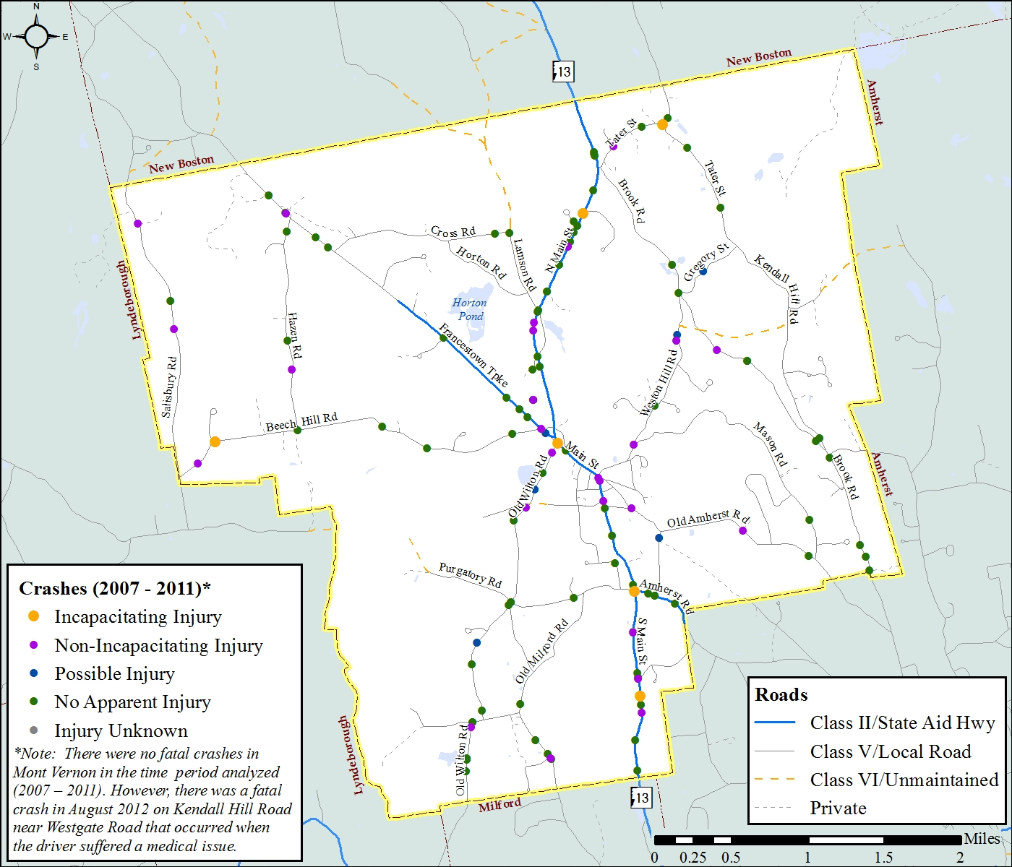
Source: NH DOT
Transportation Improvement Funding Sources

Federal Aid Programs
On July 2012, President Obama signed into law MAP-21 (Moving Ahead for Progress in the 21st Century), the first long-term highway authorization bill enacted since 2005. MAP-21 created a streamlined, performance-based, and multimodal program that addresses improving safety, maintaining infrastructure condition, reducing traffic congestion, improving efficiency of the system and freight movement, protecting the environment, and reducing delays in project delivery. Fact sheets providing details about the various funding programs are available on the Federal Highway Administration’s MAP-21 website at: http://www.fhwa.dot.gov/map21/factsheets.cfm. A summary of the programs authorized through MAP-21 is as follows:
National Highway Performance Program (NHPP): The NHPP provides support for the condition and performance of the National Highway System (NHS), for the construction of new facilities on the NHS, and to ensure that investments of Federal-aid funds in highway construction are directed to support progress toward the achievement of performance targets established in a State's asset management plan for the NHS. No roadways in Mont Vernon are designated as part of the National Highway System.
Surface Transportation Program (STP): The Surface Transportation Program (STP) provides flexible funding that may be used by States and localities for projects to preserve and improve the conditions and performance on any Federal-aid highway, bridge and tunnel projects on any public road, pedestrian and bicycle infrastructure, and transit capital projects, including intercity bus terminals. Funding is generally based upon an 80% federal and 20% state/local share. As shown in Table T-12, NH Route 13 is eligible for STP funding as a Federal-Aid road.
Congestion Mitigation and Air Quality (CMAQ): The CMAQ program provides a flexible funding source to State and local governments for transportation projects and programs to help meet the requirements of the Clean Air Act. Funding is available to reduce congestion and improve air quality for areas that do not meet the National Ambient Air Quality Standards for ozone, carbon monoxide, or particulate matter (nonattainment areas) and for former nonattainment areas that are now in compliance (maintenance areas). Portions of southern New Hampshire are designated as maintenance areas for ozone and carbon monoxide, however, Mont Vernon is outside of those areas.
Highway Safety Improvement Program (HSIP): The goal of the Highway Safety Improvement Program (HSIP) is to achieve a significant reduction in traffic fatalities and serious injuries on all public roads, including non-State-owned public roads and roads on tribal lands. The HSIP requires a data-driven, strategic approach to improving highway safety on all public roads that focuses on performance. A “highway safety improvement project” is defined by federal law as any strategy, activity or project on a public road that is consistent with the State Strategic Highway Safety Plan (SHSP) and corrects or improves a hazardous road location or feature or addresses a highway safety problem. Funding is generally based upon a 90% federal and 10% state/local share.
The Railway-Highway Crossings Program funds safety improvements to reduce the number of fatalities, injuries, and crashes at public grade crossings. Funds are derived from a set-aside of amounts calculated for apportionment to the HSIP. The Federal share for railway-highway crossing program projects is 90%.
Transportation Alternatives Program (TAP): The Transportation Alternatives Program (TAP) provides funding for programs and projects defined as transportation alternatives, including on- and off-road pedestrian and bicycle facilities, infrastructure projects for improving non-driver access to public transportation and enhanced mobility, community improvement activities, and environmental mitigation; recreational trail program projects; safe routes to school projects; and projects for the planning, design or construction of boulevards and other roadways largely in the right-of-way of former Interstate System routes or other divided highways. There is no requirement for TAP projects to be located along Federal-aid highways. SRTS projects must be within approximately two miles of a school for kindergarten through eighth grade. The federal share on TAP projects is generally 80 percent; the remaining 20% match is funded by the local community sponsoring the project.
Emergency Relief: The Emergency Relief program provides funds for emergency repairs and permanent repairs on Federal-aid highways and roads on Federal lands that the Secretary finds have suffered serious damage as a result of natural disasters or catastrophic failure from an external cause. Emergency repair work to restore essential travel, minimize the extent of damage, or protect the remaining facilities, accomplished in the first 180 days after the disaster occurs, may be reimbursed at 100% Federal share; time period may be extended for delay in the ability to access damaged areas. For eligible permanent repairs to restore damaged facilities made after 180 days, a 20% local match is required.
Transportation Infrastructure Finance and Innovation Act (TIFIA): The Transportation Infrastructure Finance and Innovation Act (TIFIA) Program provides Federal credit assistance to eligible surface transportation projects, including highway, transit, intercity passenger rail, some types of freight rail, and intermodal freight transfer facilities. The program is designed to fill market gaps and leverage substantial private co-investment by providing projects with supplemental or subordinate debt.
The TIFIA credit program may provide to States, localities, or other public authorities, as well as private entities undertaking projects sponsored by public authorities, three types of financial assistance:
- Secured loans are direct Federal loans to project sponsors offering flexible repayment terms and providing combined construction and permanent financing of capital costs.
- Loan guarantees provide full-faith-and-credit guarantees by the Federal Government to institutional investors, such as pension funds, that make loans for projects.
- Lines of credit are contingent sources of funding in the form of Federal loans that may be drawn upon to supplement project revenues, if needed, during the first 10 years of project operations.
TIFIA credit assistance may cover the following portions of the total cost of a project:
- TIFIA line of credit: up to 33%
- TIFIA loan: up to 49% (or, if the loan does not receive an investment grade rating, up to the amount of senior project obligations)
- TIFIA loan and TIFIA line of credit, combined: up to 49%
- Total Federal assistance (grants and loans) to a project receiving a TIFIA loan: up to 80%
TIFIA assistance must be repaid through dedicated revenue sources that secure project obligations, such as tolls, other user fees, or payments received under a public-private partnership agreement. Repayment of a TIFIA loan must begin by five years after the substantial completion of the project, and the loan must be fully repaid within 35 years after the project's substantial completion or by the end of the useful life of the asset being financed, if that life is less than 35 years.

State Highway Aid Programs
State Aid Funds: State Aid Funds are provided for the purpose of constructing or reconstructing sections of Class I, II, and III (state-owned) highways. This work, when requested by a municipality, would include improvements to unimproved sections of State secondary, Class II highways and Class III highways or to advance the priority of construction for special types of work such as improving drainage, riding surface, or elimination of sharp curves on Class I highways or improved sections of Class II highways. Project costs are capped at $1,050,000 and require a local match of one-third of the total cost. Unnumbered state routes which are reconstructed through this program are reclassified as Class V (town roads) upon project completion. As of Fiscal Year (FY) 2011, NH DOT is programming new projects for this program starting in FYs 2014-2015.
Bridge Aid Funds: Bridge Aid Funds consist of both State and Federal Highway Funds budgeted for construction or reconstruction of structures on Class IV and Class V highways as well as municipally-maintained bridges on Class II highways. Structures having a clear span of ten (10) feet or greater qualify for State Bridge Aid funds; Federal Bridge Aid Funds typically fund larger bridge projects. Both fund sources require a 20% local match. A total of about $13 million per year (which includes local match) has been available for funding municipal bridge projects through both fund sources. As of FY2011, NH DOT is programming new projects starting in FYs 2019-2020.
Highway Block Grant Aid: By law, all municipalities in the State having Class IV and V mileage are entitled to Highway Block Grant Aid. RSA 235:23 stipulates the funding apportionments. Highway Block Grant Aid is distributed to municipalities by the State of New Hampshire on a yearly basis with partial disbursements made four times a year. Sixty percent (60%) of the funds are distributed in the first two payments (30% in July and October) and the other 40% in the final two payments (20% in January and April). The funds can only be used for construction, reconstruction and maintenance of each municipality’s Class IV and V highways. It can, therefore, be used to be part of the match for a project in the bridge aid program. It also can be used towards equipment to maintain the local roads.
Highway Block Grant Aid funds represent a portion of the State’s highway revenues received in the preceding fiscal year. There are two “pots” of money from which allotments are made. The first, identified as Apportionment A, represents 12% of the State’s highway revenues. One-half of that “pot” is distributed among the municipalities based on their population in proportion to the entire State’s population and the other half is disbursed based on a municipality’s Class IV and V road mileage in proportion to the total statewide Class IV and V mileage. In general, the allocation of these funds represents a disbursement of approximately $1,200 for each mile of Class IV and Class V highway inventoried by each municipality and $11 for each person residing in a municipality based on the state planning estimate of population.
The formula for dispensing funds from the second “pot” of money (a set sum of $400,000) is less straightforward. It was established to assist those municipalities having high roadway mileage to maintain and whose overall value of property (on an equalized basis) is very low in relationship to other communities.
As the NH DOT is responsible for determining the actual disbursements of funds, it is important that they be provided accurate and current information regarding each municipality’s Class IV and V mileage. This is typically accomplished by filling out the “Information Report” sent to municipalities each year by the Bureau of Planning and Community Assistance. At the conclusion of each municipality’s yearly legislative meeting (i.e. Town Meeting), the NH DOT should be notified of all changes to the community’s roadway system. The information should include the length and location of all Class IV and V highways reclassified, accepted, and/or discontinued by the municipality that year. NRPC maintains an inventory of all public and private roads in Mont Vernon that is updated on an ongoing basis using Global Positioning System (GPS) and Geographic Information System (GIS) technologies. The accurate and current Class IV and V mileage collected and maintained by NRPC can be submitted to NH DOT for their use in the calculation of the town’s block grant aid disbursement.
For more information contact the NH DOT Bureau of Planning and Community Assistance.

Resources:
University of New Hampshire Technology Transfer Center
http://t2.unh.edu/
Maintains an extensive list of transportation related publications and websites, including:
- “To Pave or Not to Pave: Making Informed Decisions on when to Upgrade a Gravel Road” (2006) https://t2.unh.edu/sites/t2.unh.edu/files/documents/publications/2006PavingGuide.pdf
- "Recommended Technical Standards for New Roads" (2005) http://www.t2.unh.edu/sites/t2.unh.edu/files/documents/publications/new.pdf

Road Salt Reduction website (includes training information and links to best management practices): http://www.t2.unh.edu/green-snowpro-certification

Additional UNH T2 Resources: http://www.t2.unh.edu/resources
NH Department of Transportation Division of Project Development
http://www.nh.gov/dot/org/projectdevelopment/index.htm
The Division of Project Development houses the Bureaus of Bridge Design, Highway Design, and Planning and Community Assistance. Various guidance documents and publications providing technical and financial assistance to communities are available through each Bureau's document library, including:
- "Standard Specifications for Road and Bridge Construction" (2010) http://www.nh.gov/dot/org/projectdevelopment/highwaydesign/specifications/index.htm
- "Standard Plans for Road Construction" (2010) http://www.nh.gov/dot/org/projectdevelopment/highwaydesign/standardplans/
- "Suggested Minimum Design Standards for Rural Subdivision Streets" (2003) http://www.nh.gov/dot/org/projectdevelopment/planning/documents/SuggestedMinimumDesignStandardsforRuralSubdivisionStreets.pdf
- Local Public Agency Manual for the Development of Projects (2012) http://www.nh.gov/dot/org/projectdevelopment/planning/documents/LPAManual.pdf
American Association of State Highway and Transportation Officials (AASHTO)
http://www.transportation.org/Pages/default.aspx
AASHTO – "The Voice of Transportation" - is a nonprofit, nonpartisan association representing highway and transportation departments. Its primary goal is to foster the development, operation, and maintenance of an integrated transportation system. AASHTO publishes key documents used extensively by highway engineers and designers, including:
- AASHTO: A Policy on Geometric Design of Highways and Streets (2011) (aka the “Green Book”) https://bookstore.transportation.org/item_details.aspx?id=1917
- AASHTO: Guidelines for Geometric Design of Very Low-Volume Local Roads (ADT<400) (2001) https://bookstore.transportation.org/collection_detail.aspx?ID=29
Nashua Regional Planning Commission
Traffic Counts
http://www.nashuarpc.org/trafficcount/index.htm
Traffic volume data for the Town of Mont Vernon are compiled from several sources. The NRPC maintains an ongoing traffic count program for validating the region’s traffic model. In addition, NRPC collects traffic count data for the New Hampshire Department of Transportation (NH DOT) in accordance with federal guidelines under the Federal Highway Performance Monitoring Program (HPMS). The HPMS guidelines describe federal procedures for sampling highway and road volumes. These procedures provide the Federal Highway Administration with highway volumes for design standards and meet the Environmental Protection Agency’s requirements for estimating vehicular highway travel. The NH DOT Average Annual Daily Traffic (AADT) volume reports are online at: http://www.nh.gov/dot/org/operations/traffic/documents.htm
NH 13Access Management Study
http://www.nashuarpc.org/publications/local/MontVernon/RT13MontVernon_final.pdf
The NRPC conducted a comprehensive access management study of the Mont Vernon segment of the NH 13 corridor. The study has several goals: to document existing traffic conditions along the corridor; to utilize anticipated land use build-out scenarios to forecast future traffic conditions in the corridor; and to develop access management recommendations for the corridor based on anticipated future conditions.
Regional Bicycle & Pedestrian Plan
http://www.nashuarpc.org/publications/transpo.htm#modes)
The RBPP provides a blueprint that will guide municipalities as they work towards improved non-motorized facilities. It strives to provide an increased awareness of the economic, environmental and social benefits of increased bicycling and walking. The components of the plan support a vision for non-motorized travel in the region that recognizes the need for improved education, encouragement and enforcement, as well as the need for improved bicycle and pedestrian facilities. These components also provide a framework and an implementation strategy to make the physical and behavioral improvements that are necessary to increase the incidence of bicycling and walking in the region. Implementation of the plan will encourage an increase in the number of personal trips undertaken on bicycles and by foot, which will in turn lessen dependency on the automobile.

American Community Survey
http://factfinder2.census.gov/faces/nav/jsf/pages/index.xhtml
The ACS is an ongoing survey that provides data every year in the form of 1-, 3- and 5-year period estimates representing the population and housing characteristics over a specific data collection period. The ACS differs from the decennial Census in that the Census shows the number of people who live in an area by surveying the total population every 10 years. The ACS shows how people live by surveying a sample of the population every year. ACS collects and releases data by the calendar year for geographic areas that meet specific population thresholds; for areas with populations under 20,000, such as Mont Vernon, 5-year estimates are generated.

