Wet area

Swamp
Swamp

Carleton Pond

These are two swales [aka water ditch], in place to control excess water and overflow water, they are not drains. Both have rip-wrap rock placed in them to assist in controlling the flow [ie: slowing and allowing soil drain of water].

These installations, including the cross culvert, do not require an engineering plan; the DPW does it every year with road cross culverts.
To put it simple, you dig a ditch, place in base sand material, grade the sand, check angle drop with pipe on base material [as simple as using a level]; connect to catch basin by cutting it in and jointing the culvert and basin together. The goal of both of these swales are to control excess water and prevent that water from overflowing into the pond [which happened in 2018 with the extreme amount of rain we received].

Pond Outlet
D H

Fire
Dept.
Access
Drive
Way

Existing Culvert

[DH] Dry Hydrant
Fire Dept Access

Catch Basin New Cross Culvert

Grand Hill Road

Google map aerial view Taken prior to pond work

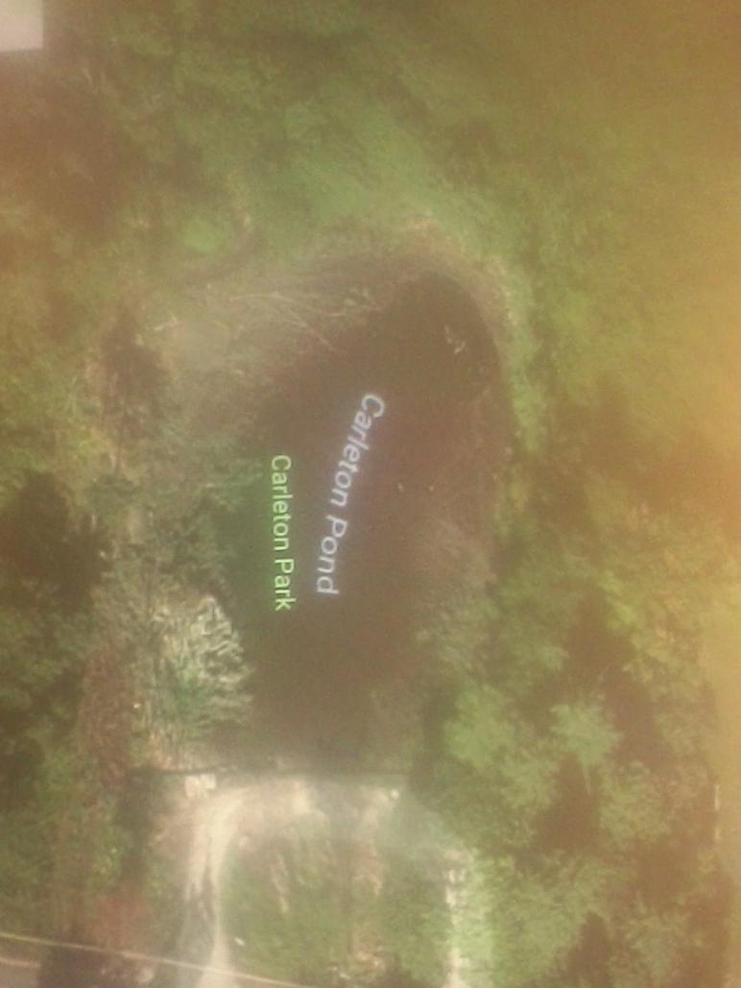
Wet areas
Swamp area

2018 Spring Fishing Derby as put on by MV DPW
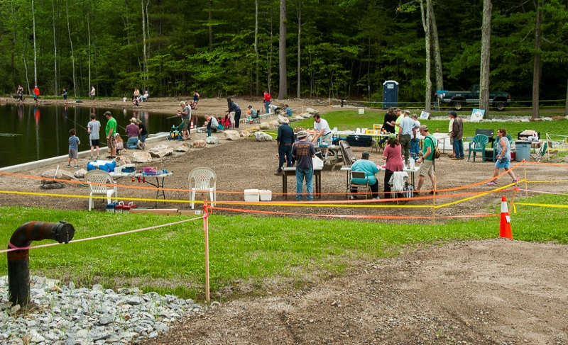

This is what rip-wrap rock is, controls surface water, helps to prevent wash outs. This swale was put in place to assist with water flow from street and field, preventing direct flow into pond
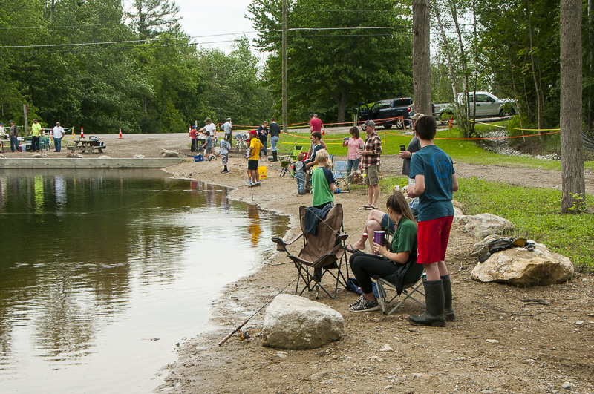
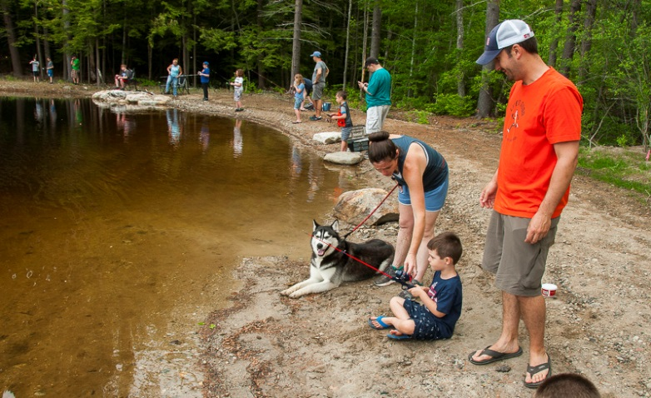
In this area, is where second swale is placed. This area will have rip-wrap stone put just like the other side.

Small bushes will be placed along the swale, just like the other side. They just need to grow.

