Organizational Meeting
Tuesday, December 17, 2019
6:42 PM

Attendees:
John Arico - Chairman Pro-Tem
Laurie Brown - Selectboard secretary
Tim Berry - Selectboard's Representative
Bill Mckinney - Member
Steve O'Keefe - School Board Representative
Scott Heinlein - Member
Jason Johnson- Member

Meeting called to order at 7:03 by John Arico

Review of the Budget
Police department is asking for a fourth full-time officer and a new cruiser.

Library is asking for an increase in salaries and also to be paid for previously un-billed hours.

Possible warrant articles:
New firetruck for the fire department - or add to capital reserve fund;
Radar speed signs for the police department.

What is the increase in Land View Management for? Spraying for invasive species.

Heritage Commission:
Wants $10,000 added to their fund and $2,500 for a historical resource survey plus $3,000 for dues, training, advertising, and supplies.

Reappraisal of property: Incresase is due to 2019 was a cyclical review year. Expected final number to be between $25,000 and $30,000.

What are the areas of concern from the selectmen: Raises for the library and full-time police officer. Selectmen recommend that the library spread their raises over two years. Selectmen support the new cruiser but haven't decided on the new officer.

Town Center Improvements - Tree in front of the Town Hall is rotting.

Department heads the committee would like to interview:
Police Chief
Library
Fire Department
Heritage Commission
Patriotic Purposes
Department of Public Works

Schedule:
Report due first week in February
Selectmen's hearing on the budget - 2nd week in February

Election of a Chairman:
Bill McKinney moves that John Arico be nominated.
Seconded by Jason.
John Arico voted in unanimously.

Bill Mckinney moves to use the following operating rules:

- All meetings will be open to the public and posted in three locations in the town at least 24 hours in advance.
- Discussion during meetings will generally be free-flowing, but, when necessary for formalities, Robert's Rules of Order will be used.
- At least three of the appointed members must be present in order to generate a quorum for a valid meeting.
- All relevant discussion regarding the town budget and warrant articles must be done at a valid Budget Committee meeting. However, discussions entailing meeting schedules and location and adding items to the agenda may be conducted outside of a public meeting.
- Only the members appointed by the Town Moderator may have a vote. The Selectboard's representative and the school board representative shall not have a vote.

Seconded by Jason

Rules are adopted.

Meeting schedule:

Tuesday, January 7th
Wednesday the 8th
Wednesday the 15th
Tuesday the 21st
Wednesday the 22nd

Any other business:

Motion to adjourn: Scott
Bill seconds

Meeting adjourned at 8:22 PM

Meeting January 7th
Tuesday, January 21, 2020
7:07 AM

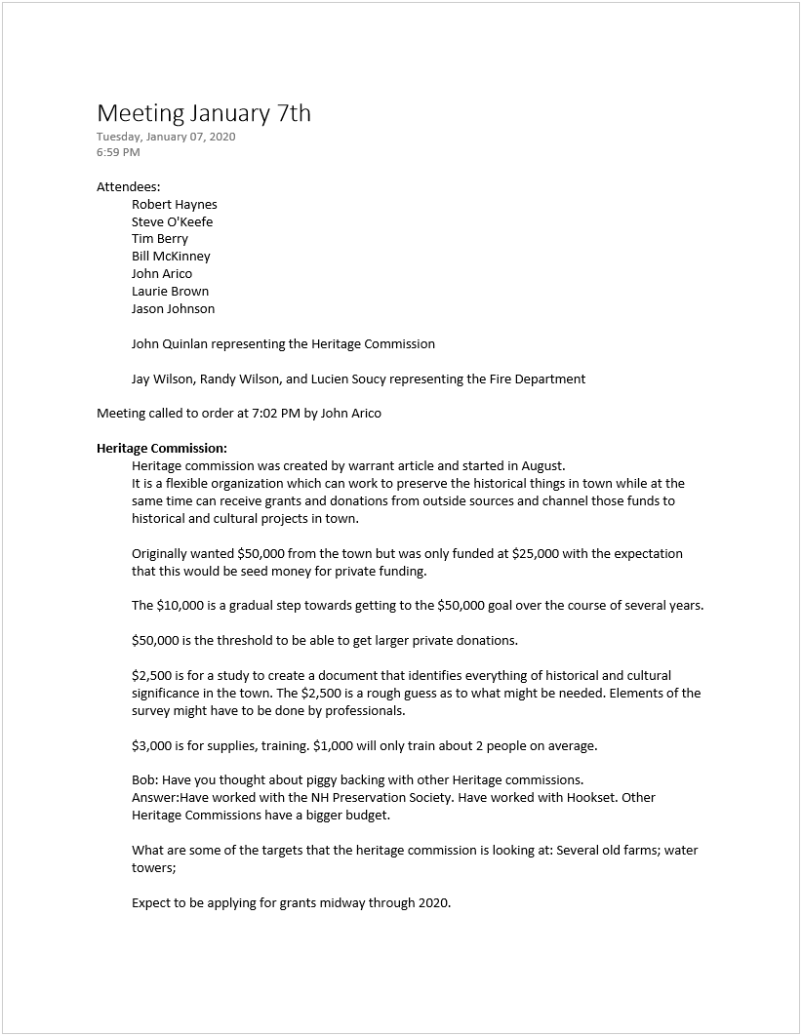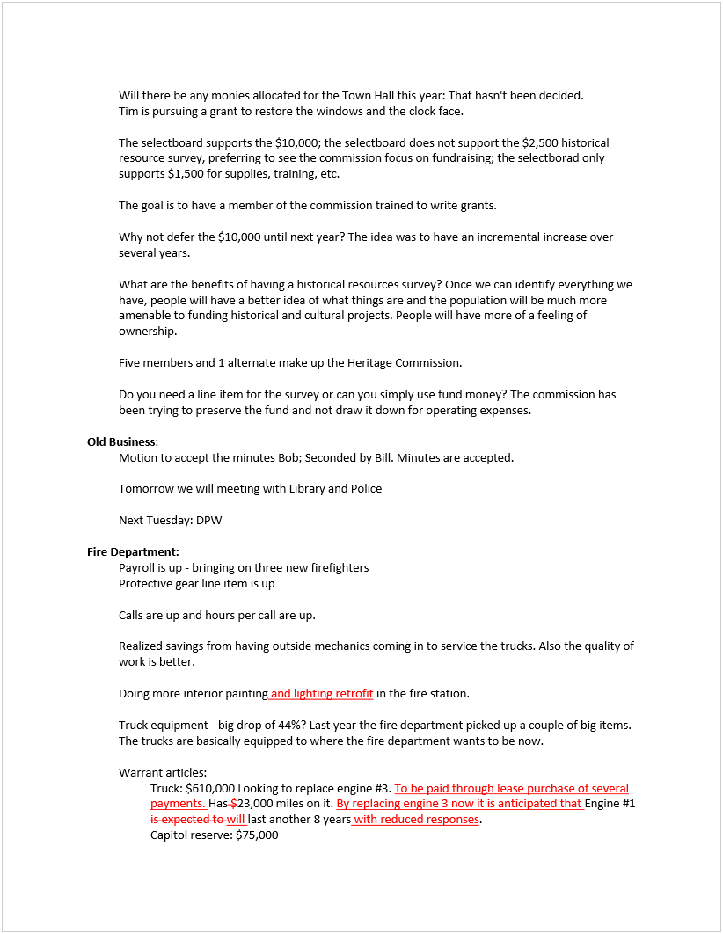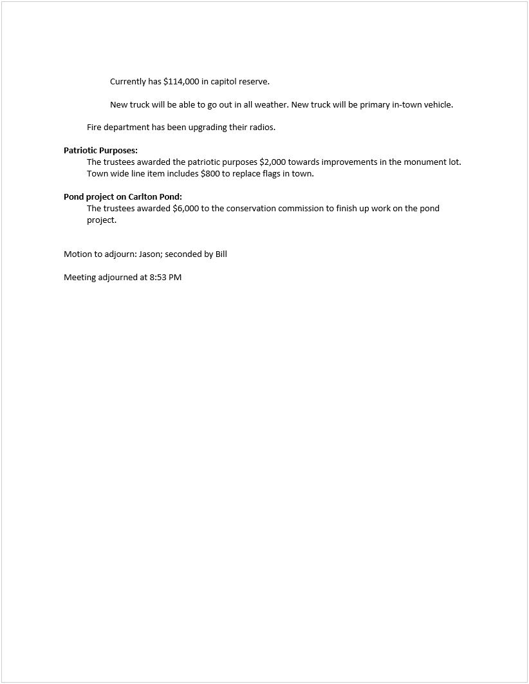

Meeting January 8th
Wednesday, January 08, 2020
6:49 PM

Attendees:
John Arico
Rob Haynes
Jay Johnson
Tim Berry
Steve O'Keefe
Scott Heinlein
Bill McKinney
Laurie Brown

Representing the library
Bonnie Angulus
Cindy Raspillier
Jane King
Jill Weber

Representing the Police Department
Chief Kevin Furlong
Sergeant Mark Slavin

Meeting called to order at 7:05

Library:
Budget Proposal
Provided a summary of wages and benefits for the 18 towns surrounding Mont Vernon.
Mont Vernon offers no benefits, only salary, and our salaries are out of sync with surrounding towns.
Staff works more hours than they are being paid for.
Daland Trust funds the library building.

Library received $5,000 community grand for the summer concert series in 2018.
Writing NHHC grants for speakers. Had two presentations: lighthouses and historic markers.

Library appropriation is books, materials, etc.

Trustees feel that the large salary increase is justified because salaries have been held low for a long time.

Steve pointed out that the increase in the number of hours for the director brings her up to the level of a full-time employee. There is a concern that a full-time employee would have to receive benefits. It is expected that the library director would waive the benefits. Retirement benefits could not be waived, though.

Approximately 1/3 of the salary increase is a rate increase, the other 2/3 is a number of hours increase.

Justification for rate increase is that, if we had to replace one of the staff members, we could not do it at the current rate.

The benefits should be funded even if the employee does not claim them.

Planning to ask for $10,000 for capital reserve via warrant article.

Selectboard's response to library budget:
Selectmen recommend $82,055 for library salaries. Basically halving the number of hours and halving the rate increase.

Police Department:
Chief furlong thanks the budget committee volunteers

Two items that need discussion:

Full Time Officer:
Last time we added a full time officer was 2004
Population has gone up.
Uniform Crime Rport says Mont Vernon should have 4 full-time officers.
Crime has changed.
Antrim has 5 full-time officers.

Although the Police department has managed to handle the workload increase, proactive crime-stopping has suffered.

Mont Vernon has no police coverage from midnight to 6 AM. We depend on State Police for coverage during those times. State Police response is slow, if at all.

It costs $32,000 to hire and train a new officer. Other towns are having a difficult time finding new officers.
We have a part-time officer in our community who is already certified. He can hit the ground running and Mont Vernon can avoid the $32,000.

In 2009, the police department brought in almost $75,000.
The new part-time officer would be paid for for two years from work details for Eversource.

The selectboard supports the fourth officer.
The fourth officer will allow for coverage when school is in session and an officer has to be elsewhere.

The select board does not support the new cruiser.

If the current opportunity falls through, the police department would have to push back the starting date in order to hire a new officer at the requested funding levels.

Equipment:
Budgeted 2 tasers at $1400 each. Current tasers are no longer supported by the manufacturer. Phasing in new tasers. Last year purchased 2, this year planning to purchase 2, then 1 each year for the next four years.

Cruiser:
Equipment $16,500 50% of purchase cost of new cruiser.

Cruiser upfitting $20,860.
Ford no longer makes the sedan police cruiser. Cannot move existing equipment from existing cruisers to new cruiser. Have to purchase all new equipment to fir new cruiser.

Asked to choose between a fourth officer or cruiser, the police department chooses fourth officer.

Would trade out 2014 cruiser for new one.

Chief believes we need both the new officer and new cruiser.

Not getting a new cruiser means that maintenance will be more expensive. Chief would recommend adding $1,500 to $2000 to line item for maintenance of the 2014 Ford Interceptor.

Motion to adjourn: Bill; Jason seconds

Meeting adjourned at 9:23.

Meeting January 15th
Tuesday, January 14, 2020
10:15 PM

Agenda

- Review DPW budget
- Old Business
  - Review minutes of January 7th meeting
  - Review minutes of January 8th meeting
- New Business
  - Discussion of whether or not to change the operating rules to allow the School Board representative to have a vote on the Town Budget Committee

Attendees:
Laurie Brown
Steve O'Keefe
Tim Berry
Bill McKinney
Scott Heinlein
Robert Haynes
John Arico
Jay Johnson

Representing DPW: Ben Crosby

Meeting called to order at 7:08

Review budget for the DPW
About a 10,000 increase. Most of that is the addition of calcium chloride. This is an experimental dust control treatment for dirt roads. Can be used as a pre-treatment option for treating all roads in the winter.

An aggressive program would cost 17,000 for a year.

The 9,500 cost gives the DPW a good basis for their dust control program.

There is no reduction in this year's budget due to the anticipated benefit from the calcium chloride. Could begin to see a benefit in three years.

Sand and Salt line item was low in 2019. It was high in 2019 die to all the freezing rain at the beginning of the year.

Calcium chloride will not be stored on site this year. If we went with the more aggressive option, it would be stored in 4,000 gallon poly thanks.

Tarring and Sealing has remained the same for several years. Ben works with a paving company to keep the price level.

Road and Pavement markings. Couldn't spend much due to weather.

Sanitation:
Landfill charges went up 18,000 due to cost of disposal going up. Having the new compactor has helped reduce the use of the open top container.

Miscellaneous line item includes cost of a compactor for the plastic recycling.

Added cost of electricity for the compactor is included in the Transfer Station electricity costs.

The increase in full time wages is due to the addition of 1 part-time position.

Ground Maintenance and Tree Work: Includes the green, ball field, fire station, town hall and McCollom Building.

Fuel costs: State shed is expensive. DPW has not looked into the card system (fleet card) to lower costs.

Town gets block grant money from the state.

The DPW budget seems pretty lean. Radio line item has gone up due to costs of radios going up.

Telephone and pager line going up due to upgrading from pagers to cell phones. Service will be AT&T.

Review of minutes:
Bill McKinney offered a set of amendments to the January 7th minutes.
Motion to accept minutes: Jay; seconded: Scott Minutes from January 7th are accepted as amended; Minutes from January 8th are accepted as written.

School Board Representative voting:

Reason for allowing a vote: School Board allows the selectmen's representative a vote on their opinions. School board representative is a citizen of the community. School board representative participates in the discussion.

Reasons for not allowing : If we allow only the school board representative a vote, that would be an even number of voting members and that could result in a tie vote.

Bill supports giving the SBR a vote; Jay supports;

Motion to change the operating rules 2 and 5 as follows By Bill, Seconded by Jay :
- No change
- No change
- At least four of the voting members must be present in order to generate a quorum for a valid meeting.
- No change
- Only the School Board Representative and the members appointed by the Town Moderator may have a vote. The Selectboard's representative shall not have a vote.

Motion approved.

New business:
Tim: We had a discussion with the Police chief. Clarification: Two requests were for a 4th officer and the new cruiser. The Police chief had stated that if the budget committee or the Selectmen do not support both the fourth officer and the cruiser, he would rather have the fourth officer.

Tim Clarified this: If either the selectboard or the Budget Committee do not support the cruiser, the Police chief would not lobby for it, but he would still leave it in his budget.

Laurie: Updates from Selectmen:
Town Clerk's Salary: Town Clerk is asking for a raise this year. 2% Bringing her stipend up to $26,640.
Assessing and Pickups (415210) went from 35,000 to 20,000.
Cemetery(419580) Special Projects: Will come down to ~11,500 will be covered by Cy-Pres.
Regarding the library payroll: selectboard supports
455010 Library Payroll: 82,055
455013 Retirement: 0
455014 Health Insurance 0
455020 FICA/Medicare: 6280

The reason for splitting the increase in pay was to incrementally adjust the salaries over time. The reason for cutting the hours in half was 1) to prevent one of the employees form going full-time. And also to bring this up incrementally.

Heritage commission: Selectmen favor $10,000 for the fund. Currently is a line item. Selectmen had a discussion as to whether this should be a warrant article. It it is a line item, the selectmen have the freedom to push more money into the fund if the opportunity for a grant comes up. It it is a warrant article, and it gets voted down, they cannot do this. The selectmen support cutting the remaining line items in half and eliminating the historical resource survey.

Report on the School Budget:
Is going up between 6.8% and 6.97%: Between 353,000 and 359,000

School saw an increase of 24 students. There was also an increase in the number of students in special ed.
Tax impact is expected to see a 52 cent drop in mil rate.

Next Meeting: Tuesday the 21st. At 7:00

Motion to Adjourn Bill; Seconded by Scott

Meeting adjourned at 9:07

Meeting January 21
Tuesday, January 21, 2020
7:07 PM

Attendees:
John Arico
Laurie Brown
Tim Berry
Jay Johnson
Steve O'Keefe
Robert Haynes

Meeting called to order at 7:11 by John Arico

Acceptance of January 15th minutes tabled until the 22nd.

Review of Budget:
Town Clerk:
Line item 414210 - Includes a 2% increase over last year. Selectboard opposes and will reduce this to $26,120 for the budget presentation. Selectmen are basing this on the Town Clerk's statement at Town meeting last year that she will not seek an increase in her stipend.

Deputy Town Clerk: Line Item 414211: Includes a 2% increase in the hourly rate and an allowance for the extra hours needed due to this being an election year.

Training: Line item 414212: $915 needed in case the Town Clerk needs to train a new deputy.

Discussion of Town Clerk's Budget tabled until Wednesday evening.

Selectmen's Office:
Archival is the hardcover books of the town reports.

Website hosting went up in anticipation of improvements to the website.

Employment screening is drug testing. Went up $1,000 because quarterly screening has started. Random drug testing was not performed in prior years.

Legal Expenses: Discussion of whether $10,000 is enough considering the expected deals needed to be made in relation to refurbishing the Town Hall. Could possibly be funded via the warrant article.

Police Department:
Jay is in favor of keeping the cruiser in the budget so as not to be shorthanded on vehicles. Also says that the police chief made a very good justification for the fourth officer.
Police department's overall budget is going up 15%. Expect to have a discussion of this at Town Meeting.

Selectboard backs the fourth officer. But not the Cruiser

Budget Committee votes three in favor of the cruiser with one abstention.

Library:
Robert supports the Library budget as proposed by the Library Trustees.
Steve Supports it.
Jay supports the budget as proposed by the library.
John does not support increasing salaries by 15% in a single year.
By a vote of three to one, the Budget Committee Supports the budget as proposed by the library

Heritage commission:
Steve: Would rather reduce $10,000 to $1, and use building maintenance funds to attract grants.
Tim would like to keep the $10,000 so as to have a base of funds to attract matching grants to cover work on windows and the clock face in the Town Hall. However, the funds are under the control of the Heritage Commission and the Selectboard would have to negotiate with them in order to release them.

Why not put the money into the maintenance budget? Tim says that the Grantors want to see funds earmarked for preservation.

There is already $25,000 in the Heritage fund.

Steve: No one is ready to write grants; Because training won't occur until the Spring, they will miss the window for grant writing.

Three choices before the Budget Committee:
- Accept Selectmen's budget
- Accept Heritage Commission's budget
- Reduce Heritage Commission fund to $5. Leave other line items the same as the selectmen's version.

Motion to adjourn: Rob; second Jay

Meeting adjourned at 9:09 PM

